BIOLOGY DEPARTMENT
NAMUNGOONA SALAF SEC.SCHOOL
ENZYMES TEST 1
12th June,2020

1.Hydrogen peroxide can be broken down into water and oxygen bubbles to form a froth as shown below when a piece of fresh irish potato cube is placed in a testube containing 5cm³ of Hydrogen peroxide
2H₂O₂ 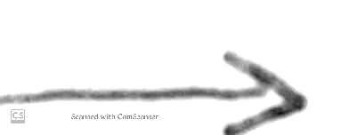 0₂ + 2H₂O₂
Graph a shows the variation of the length of the froth formed with time
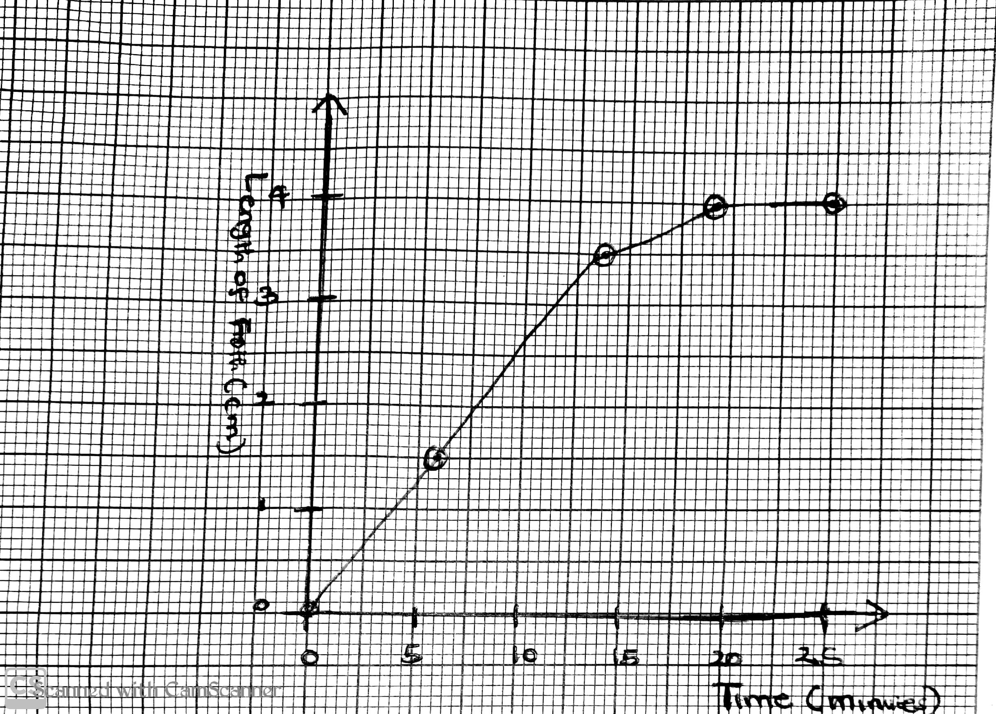
Graph a

In another experiment, the testube containing the fresh irish potato cube and hydrogen peroxide was placed in a water bath and the volume of oxygen given out was recorded at different temperatures as shown in graph b
Graph b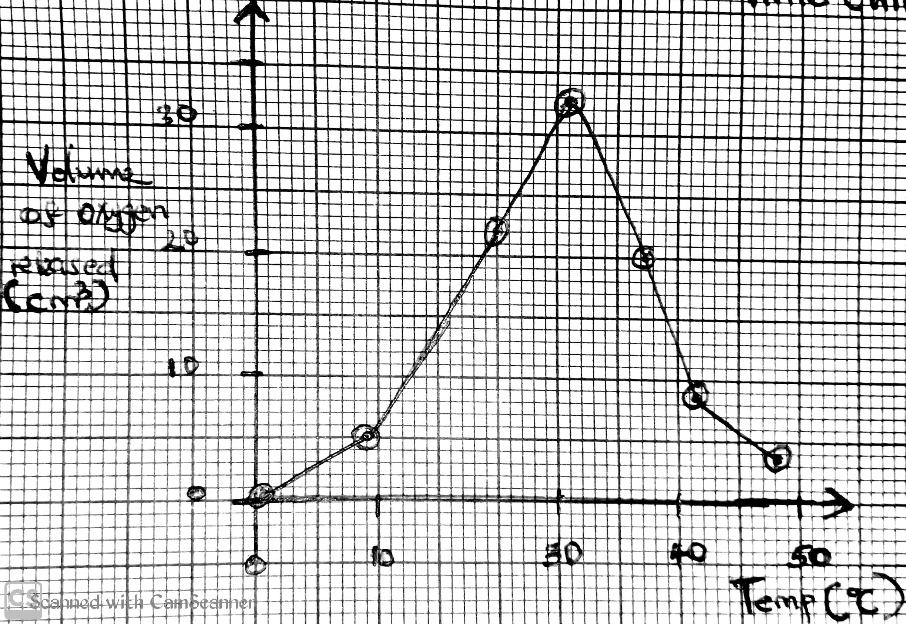

a) From the graph a
i) Describe the variation of the length of froth formed with time (03mrks)
................................................................................................................................
................................................................................................................................
................................................................................................................................
...............................................................................................................................
ii) Give an account for the variation of the length of the froth formed with time (06mrks)
................................................................................................................................
...............................................................................................................................
................................................................................................................................
...............................................................................................................................
................................................................................................................................
...............................................................................................................................

b) From graph b below , give an account for the changes in the volume of oxygen produced with temperature between:
i) 0ºC to 10ºC (02mrks)
................................................................................................................................
...............................................................................................................................
ii)1 0ºC to 30ºC (02mrks)
................................................................................................................................
...............................................................................................................................
iii) 35ºC to 40ºC (02mrks)
................................................................................................................................
...............................................................................................................................
ci) Where in the living cells does the above reaction take place (01mrks)
................................................................................................................................
...............................................................................................................................
ii) State the significance of the above reaction (02mrks)
................................................................................................................................
...............................................................................................................................
d) Identify the nature and the property of the active substance 8nthe irish potato (02mrks)
................................................................................................................................
.............................................................................................................................
2. An experiment was carried out to investigate the effect of pespsin enzyme on Albumin. The following were done as summarized in table 1
Beaker A | Beaker B | Beaker C
- 1cm3 of Hydrochloric Acid  - 1cm3 of Pepsin  - 4cm3 of Albumin | - 1cm3 of Hydrochloric Acid  - 1cm3 of boiled pepsin  - 4cm3 of Albumin | - 1cm3 of sodium hydroxide  - 1cm3 of pepsin  - 4cm3 of Albumin

The beakers were placed in a water bath maintained at 370c and a ft er, 20 minutes, a Burretes test was carried out onto the contents of each beaker
a) Explain what is observed to the contents of each beaker after a Burrete's test
i) Beaker A(03mrks)
................................................................................................................................
...............................................................................................................................
................................................................................................................................
...............................................................................................................................
ii) Beaker B (02mrks)
................................................................................................................................
...............................................................................................................................
................................................................................................................................
...............................................................................................................................
iii) Beaker C (02mrks)
................................................................................................................................
...............................................................................................................................
................................................................................................................................
...............................................................................................................................
b) Explain why
i) The setup was left to stand for 20 minutes
................................................................................................................................
...............................................................................................................................
ii) It was neccessary to keep the beakers at 370C
................................................................................................................................
...............................................................................................................................
iii) Name the organ that produces pepsin
................................................................................................................................
...............................................................................................................................
3a).Define an enzyme(02mrks)
................................................................................................................................
...............................................................................................................................
b) List any 5 properties of enzymes (05mrks)
................................................................................................................................
...............................................................................................................................
................................................................................................................................
...............................................................................................................................
................................................................................................................................
...............................................................................................................................
c) List any 3 factors that affect enzyme activity (03mrks)
................................................................................
...............................................................................
..............................................................................
Section c

4. Describe the factors that affect enzyme activity
5 Describe an experiment to show that temperature affects enzyme activity

